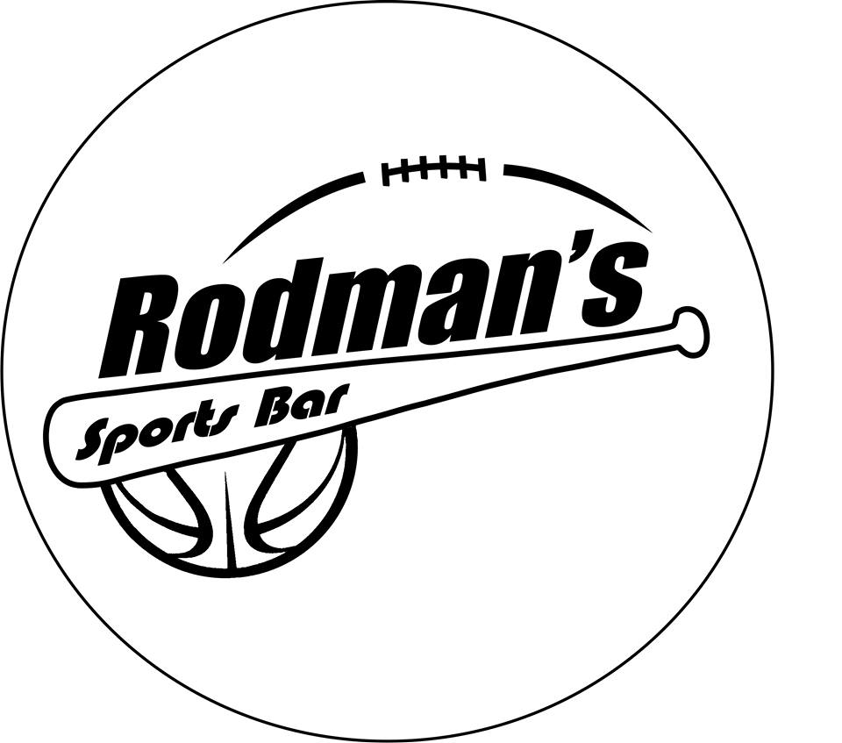

ALL INCLUSIVE BAR STOOLS FOR 4 PEOPLE.
*Excludes August 4th*

